## Commands Utilities

This assignment expects the participant to identify specific command(s) OR perform the given action using one or commands as per the given question. You are requested to maintain the answers (i.e command(s) as per given question) for all questions below.

**Mandatory Questions**

1. Which command is used to know the current working directory?

Ans: The command used to know the current working directory is pwd (present working directory).



1. How would you find out its contents?

Ans: The contents of the directory can be found using commands like

1. ls: to list the contents of the directory
2. ls -la: to list the contents in the directory including the details and also including the hidden contents.
3. ll: to list the contents in the directory including the details and also including the hidden contents. (only in linux)

1. Identify the commands with inputs to do the following
   1. create a directory d1
   2. create a subdirectory d2 in d1
   3. change to directory d2
   4. create an empty file “f1.txt”
   5. display the contents of “f1.txt”
   6. view the contents of d1 from current directory d2

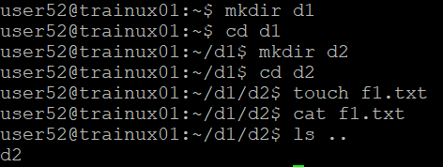

1. Use the ls command with its options. How will you identify directories from the listing?

Ans: The ls commands used with options are

1. ls -l: directories have d mentioned at the start in the file permissions

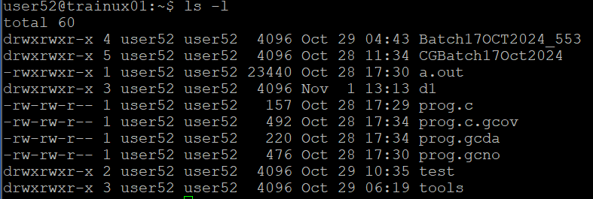

1. ls -F: directories have ‘/’(slash)



1. Use ls to do the following
   1. List files with single character names.

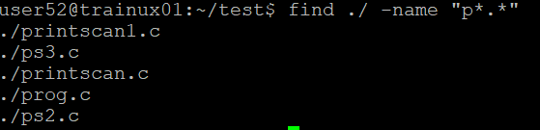

This command used to shows all the files whose name starts with p. As we have * all types of extensions are also included

* 1. List hidden files also. [ Note : Hidden files are files having name started with a “.” ]

* 1. Suppose there are files tb1.1, tb2.1, tb3.1, ….tb10.1. Write command to list all the files [Hint: use wild card characters]

ls tb*: used to list all files in the directory starting with tb

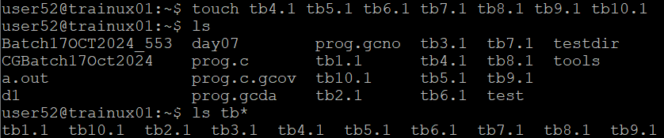

1. Write the command to list all files in descending order of their size.

Ans: The command used to list all files in descending order of their size is **ls -lS**

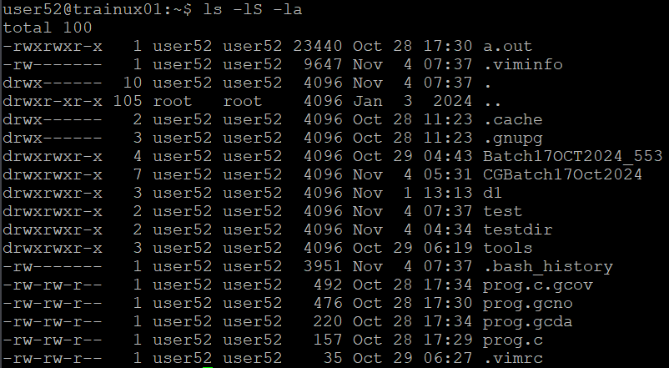

1. Suppose there are files temp1, temp2, temp3. Write command to remove the files without listing them explicitly

Ans: rm t*.* command is used to remove the files starting with t with any extensions without listing them explicitly

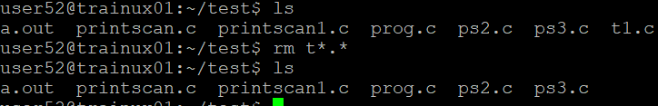

1. Which command is used to list top few lines in the file?

Ans: Head command is used to list top few lines in the file.

1. head filename: display the first 10 lines in the file(by default)

1. head -n 5 filename: display the first 5 lines in the file

1. Create a directory “testdir”

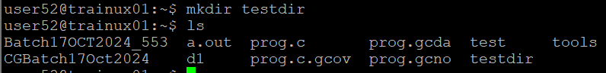

1. Use cp command to do the following
   1. Copy the file tb1.1 (created above) in the same directory.

Ans: To copy the file we use cp command as cp (source path) (destination path)

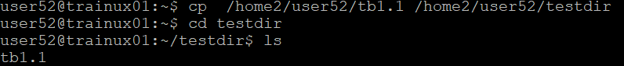

* 1. Write a command to copy all the files i.e tb1.1,tb2.1,tb3.1,…..tb10.1 in a new directory –“new”
  2. Create a subdirectory in new in named“new1”.
  3. Write a command to copy selectively only tb2.1, tb6.1, tb7.1 and tb10.1 in the directory new1.
  4. Write a command to copy the entire directory “new” to a directory “newprogs”. [Note : use the –R option of “cp” command ]

1. Find out the difference between
   1. “mv” & “cp”

Ans: **mv command:**

* Stands for move or rename
* Used to move files or directories to a different location and can also used to rename the files
* Syntax: mv source destination

**cp command:**

* Stands for copy
* Used to copy files or directories to a different location
* Used as duplicate or backup files
* Syntax: cp source destination
  1. “rm”, “rmdir”

Ans: **rm command:**

* Stands for remove
* Deletes files and directories
* Syntax: rm [options] filename

**rmdir command:**

* Stands for remove directory
* Deletes empty directories only
* Syntax: rmdir filename
  1. “mkdir” and “mkdir -p”

Ans: **mkdir command:**

* Creates a new directory
* Syntax: mkdir directory name

**mkdir -p command:**

* Creates a new directory and its parents if they don’t exist
* Syntax: mkdir -p directory name/path

12.Use a single command rmdir once to remove “testdir” and all its sub directories and files created above.

13.Which command is used to get the manual information of a command?

Ans: The command **man** is used to get the manual information of a command

Eg: man git

14.If you are not able to change to a directory what could be the likely cause?

Ans: the causes for not able to change to a directory can be:

* Directory does not exist or has been deleted
* Lack of execute permission on the directory for the user or group
* Incorrect path or mistake in writing the directory name

15.Explain the differences among the following commands:  
              a. cd / : change directory to users home directory

b. cd .. : change directory to parent directory

  c. cd : change directory to users home directory. Same as cd /

  d. cd ../..  :change directory two levels up

**Advanced Optional Questions**

1. How could you display the inode number of a file?

Ans: **ls -i** command is used to display the inode number of a file

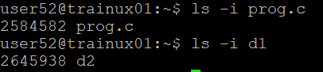

1. What is the pipe symbol? What effect does it have?

Ans: The pipe symbol is ‘|’. It redirects the output of one command as input to another command

1. Find out the details of “ps” command ?

Ans: ps stands for process status. This command is used for viewing information about running processes